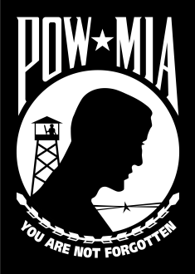

The WALK OF HEROES/Veterans War Memorial will host a   
Memorial Day Ceremony at Black Shoals Park in Conyers, Georgia.  
  
**Monday, May 25, 2015 at 7:00 p.m.**   
 (To Avoid The Heat)   
  
**To Honor America’s**  
**147th Annual Memorial Day**  
  
Speaker  
Senator Hunter Hill  
Chairman of the Georgia Senate’s   
Veterans Affairs Committee  
  
Visit our Website, www.walkofheroes.org

For More Information call 404-401-7142

**Monday, May 25, 2015**

**Memorial Day Ceremony**